Pre-Reading

**The End**

The first word that should be new is 面对 (mian4dui4) the first character 面 is a pictograph for a face the inside of the character has a 目 (mu4) which means eye, the 目 is surrounded by a border suggesting a face. The second character 对 has many meanings, we have seen it as “correct” and “counter” together with 面it means to face something or to confront something or someone. The next character is 件 is a measure word for 事. The next word is 需要 (xu1yao4) this word should be compared with 要. Remember 要means to want or will, 需要 simply means to need. So you could say我需要你 I need you, or you could say 我需要一个桌子I need a desk. The next word is 笑着 (xiao4zhe) the first character 笑 means to laugh or smile, usually only context will tell you the difference. If I say 他笑我it means he is laughing at me, if I say 他笑 smiles. The second character 着 tells us that the action is currently happening. The next word is 捐 (juan1) notice the hand radical on the left it is the same as in 打. This character means to donate, so you can imagine someone handing money to a homeless person to remember this character. The next word is 帮助 (bang1zhu4) which means to help, the second character 助 means to assist, and you should notice the 力radical on the right which means strength, so it takes some strength to assist people. The last word is phrase 什么都没有 (shen2me dou1 mei2you3) this literally means “what all no have” but it will translate to “have nothing at all.” So if someone asks you for money you could say “我什么都没有.” This reading will conclude the story. Your following readings will be authentic texts from China, remember you still have 10 more to do for the end of the semester, any readings after the ten will be considered extra credit.

Story Character Count = 112

Vocabulary/Writing

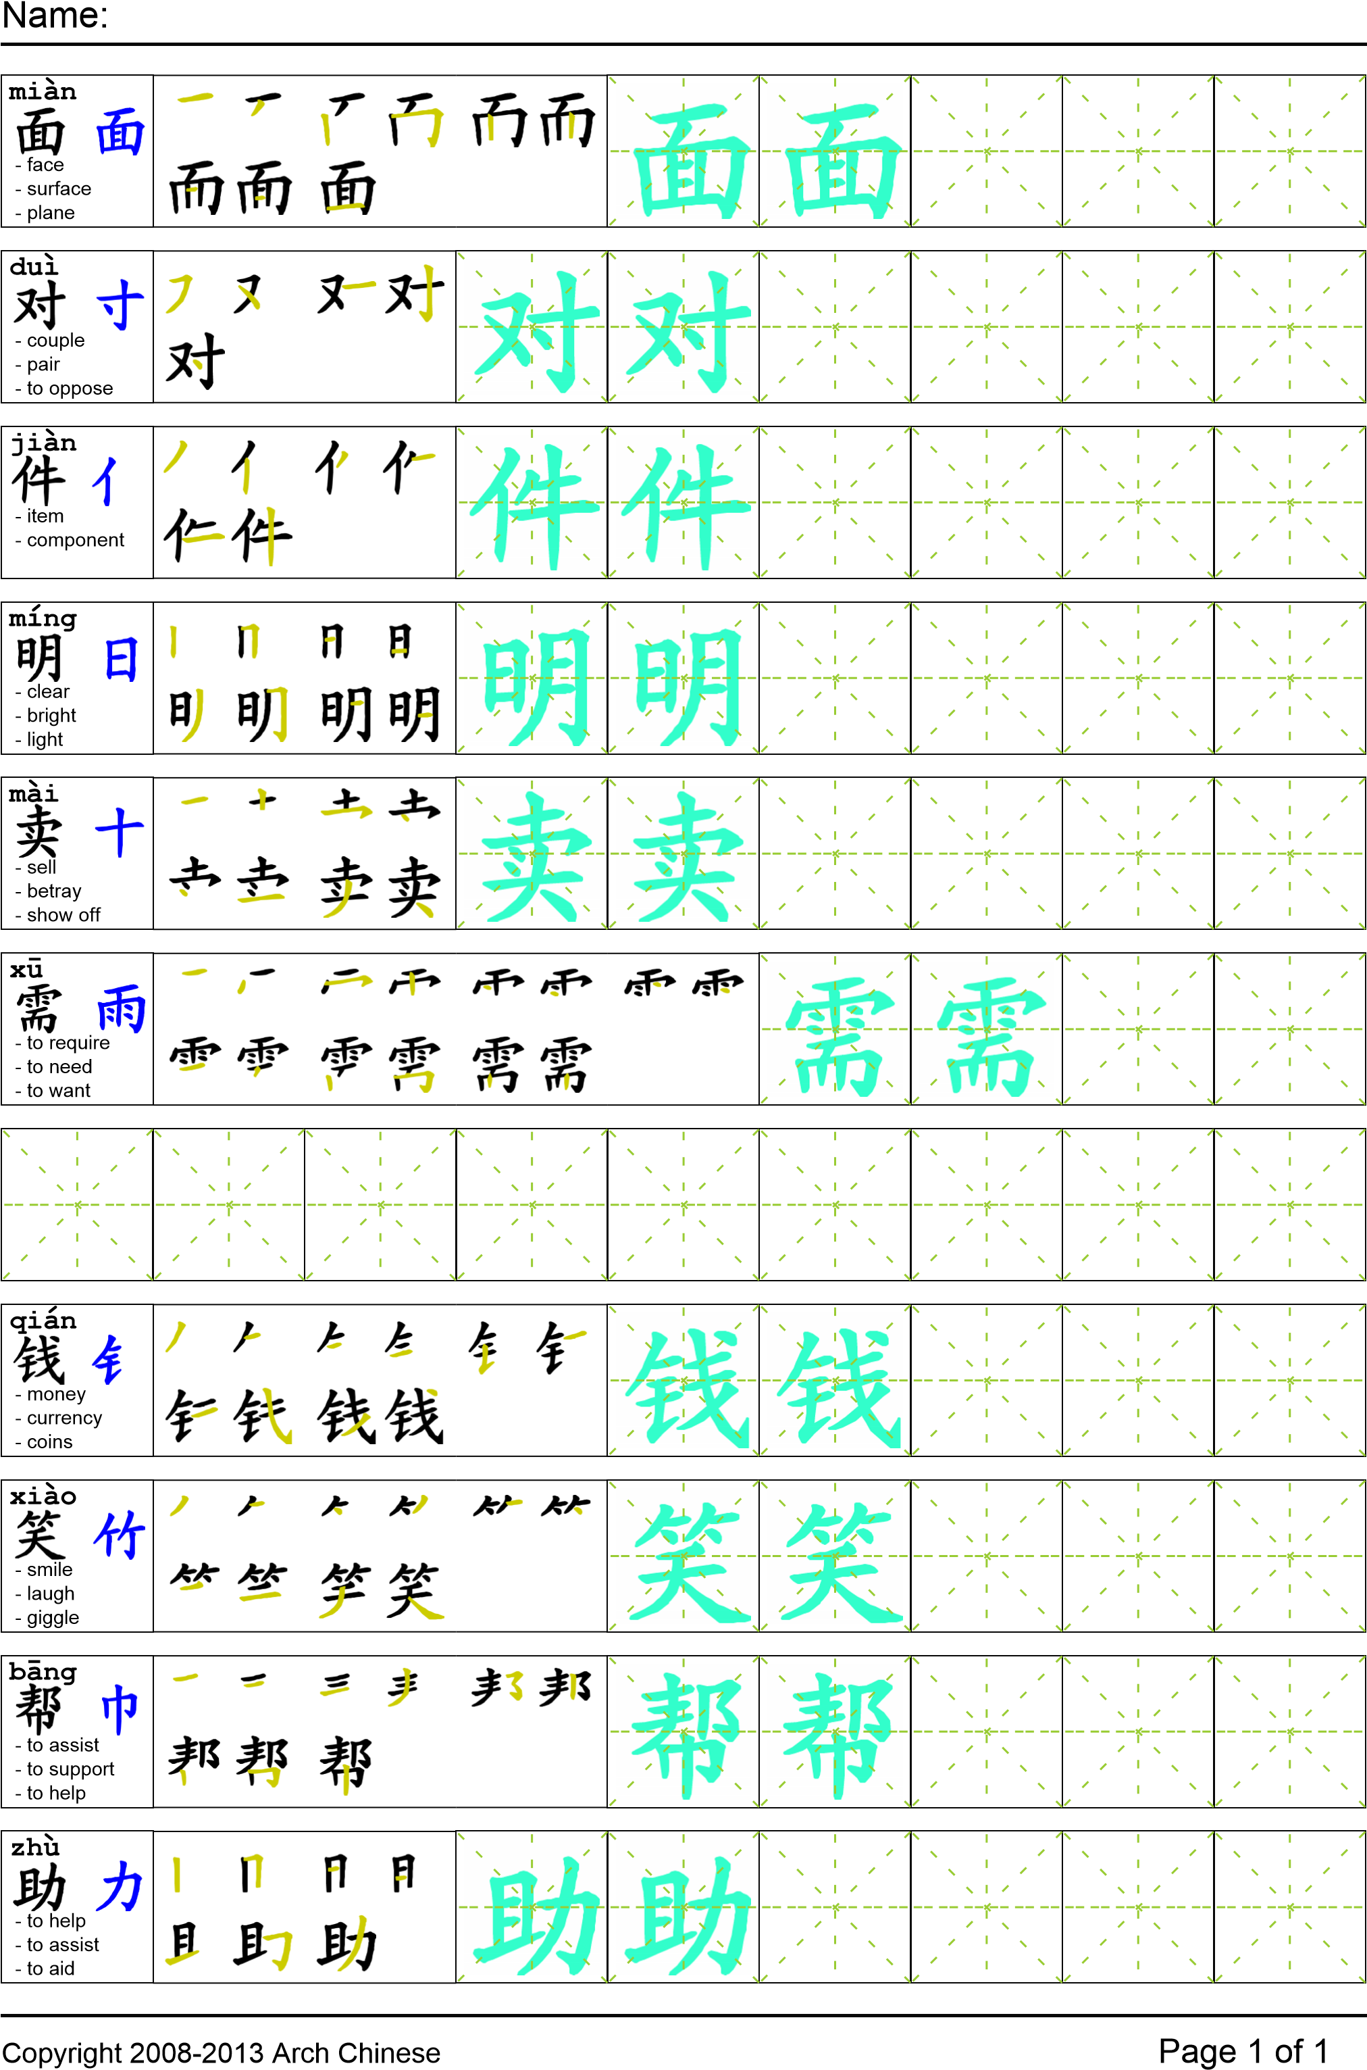

Reading

我妹妹回家的时候我们一起去面对妈妈。跟她说“妈妈别做那件事，你肯定会后悔的！”妈妈说“我不明白你在说什么。”我说“别卖给别的国家那些偷来的东西，我们不需要那个钱！”妈妈笑着说“我不卖我要捐给他们。有些孩子在别的国家什么都没有！我要帮助他们，所以我捐学校用品”

Task Completion

Once all tasks are complete turn the assignment in to collect the points for the project.

Task 1: Trace the vocabulary

Task 2: Answer Comprehension Questions

Task 3: Write the Pinyin for the Reading

Task 4: Translate the Reading into English

Task 5: Record yourself reading the passage twice

**Comprehension Questions**

1. 用“需要”写两个句子.
2. 谁是小偷？
3. 妈妈为什么偷东西？
4. 你觉得这个故事怎么样？